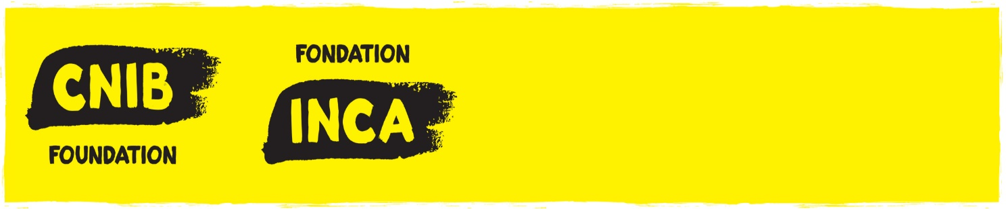

ROSS C. PURSE DOCTORAL FELLOWSHIP

APPLICANT'S NAME:

DEGREES HELD (Starting with your most recent degree first, please indicate the month & year attained, name of program and of University):

NAME OF CURRENT PROGRAM OF STUDY:

INSTITUTION:

FACULTY:

DEPARTMENT:

ADDRESS (including Country):

TELEPHONE:

E-MAIL:

CITZENSHIP (Note that Canadian students studying abroad are eligible, as are Canadian citizens, permanent residents and international students studying in Canada):

NAME OF THESIS SUPERVISOR:

COMPETITION DATE: 2021

TITLE/NAME OF PROJECT:

ABSTRACT: (A brief, non-technical description of your research in max 500 words, written in simple and clear language suitable for a lay audience. This will be posted on the CNIB website if awarded):

RESEARCH OUTLINE ATTACHMENT:
Complete the following questions on this form. For item 2 (“Outline of proposed program”), please attach a research outline of no more than 10 pages, single spaced (5,000 words, not including references, figures or tables). Applications that exceed 10 pages will not be considered.

- Indicate which discipline(s) your proposed program is closely related to. If the field of study is multidisciplinary, specify related disciplines. Please note that only applicants studying in a field or conducting research on a topic relevant to vision loss and the lived experience of persons with vision loss will be considered. Broadly, this includes biomedical research, rehabilitation research, behavioural and psychosocial research, social sciences, human-computer interaction, accessibility research, inclusive design research and other related disciplines.
i) Degree sought:
ii) University to award degree:
iii) Department:
iv) Where will you be during the period for which you are seeking support?
- At the university to award degree:
- Elsewhere (specify):

- Attach the outline of proposed program which should include:
- Specific interest area within your discipline
- Title of thesis, if known.
- If you are doing course work, please attach a concise statement of how your course work relates to vision sciences and how your future doctoral work will orient and contribute to this field of study. If you are writing your doctoral dissertation, please attach a concise statement of how your dissertation is an original addition to the literature and knowledge that currently exists within the field of vision loss.
- Please include approvals by the University and/or Research Ethics Board approvals for your project, if any.
- Indicate what you hope to accomplish during the period for which you
are seeking support.
- Indicate your career aspirations after completion of your graduate or doctoral degree.
- If you have published or co-authored any papers or articles related to your proposed field of study, please include copies with your application.

SIGNATURE OF APPLICANT REQUIRED (digital signature accepted):

I declare that to the best of my knowledge, the information provided in this application and attachments is true and no material fact has been withheld.

Signature of Applicant: Date:

ADDITIONAL SIGNATURES REQUIRED (digital signature accepted):

Signature of Dept. Head or Supervisor: Date:

Print Name:

ALL APPLICATIONS MUST BE ACCOMPANIED BY:
- Applicant’s complete curriculum vitae and publication list;
- Letter of support from Head of Department and/or Host Research Facility
- Letter from department or health facility verifying academic appointment, or position at health facility, or co-applicants appointment or position;
- Letter of concurrence (if different from home university) from Institute where research will be undertaken;
- Proof of citizenship;
- Letter of acceptance from institution where advanced training will be taken;
- Confidential reference letters from the following persons:
  - Thesis Supervisor or Director of Studies, AND
  - Another faculty member
- Official Transcripts (from University for evidence of applicants’ academic standing).

All applications must be sent by email NO LATER THAN SEPTEMBER 24, 2021 to:

Cheryl-Ann Ali
Executive Assistant
CNIB
1929 Bayview Avenue
Toronto, ON M4G 3E8
E-mail: cheryl-ann.ali@cnib.ca

