Bancroft Institute for Studies on Workers’ Compensation and Work Injury

Pre-existing or related? Workplace injury and chronic health conditions.

Tuesday, October 3, 2017

Save the Day!

Keynote: Diagnosed Chronic Health Conditions among Injured Workers
Becky Casey and Peri Ballantyne

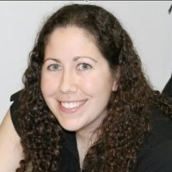
Becky Casey has a PhD in Sociology from McMaster University. Her research areas of interest are aging, disability, work injuries, and health. She uses qualitative and quantitative research methods to study the health experiences of injured workers. She recently published a study with Peri Ballantyne entitled Diagnosed Chronic Health Conditions among Injured Workers with Permanent Impairments and the General Population in the Journal of Occupational and Environmental Medicine.

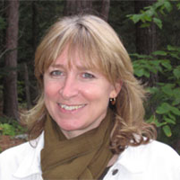
Peri Ballantyne is an Associate Professor in the Department of Sociology at Trent University. She currently teaches sociology research methods, the sociology of health and illness, and the sociology of medicine. Her current research is focused on the lay experience of illness (with a particular interest in pharmaceutical use) and the sociology of work and health.

Workshop Objective

To share the latest information from both health care and legal perspectives on the issue of pre-existing conditions and workers’ compensation, and to inform those considering submissions for the upcoming WSIB review of the pre-existing conditions policy.

Registration Required

Registration fee for the waged and students: TBA
RSVP to BancroftInstitute@gmail.com
Tokens are provided for the unwaged.

Please avoid wearing scents or fragrances when attending the workshop.

Agenda

The workshop is a full day (10:00 am – 4:00 pm).

10:00 Introduction to the day
10:15 Keynote presentation
10:45 Injured worker commentary
11:00 Audience discussion/questions
11:30 OHCOW doctor presentation
12:00 Injured worker commentary
12:15 Audience discussion/questions

12:30 Lunch

1:15 Panel presentation on pre-existing conditions, class action lawsuits and related legal issues in workers compensation law and policy
2:00 Audience discussion/questions
2:15 Breakout sessions to assist participants in preparing submissions for the policy review
3:30 Report back and wrap-up

Workshop Locations

Friends House
60 Lowther Avenue, Toronto, Ontario

Wheel chair access from Bedford Road (through parking lot at back of building)

