Willing but unable: a population in waiting

July 2016

Acknowledgements

We acknowledge with thanks the financial support of the Centre for Research on Work Disability Policy (CRWDP) through a SEED Grant. We also are very appreciative of the contribution made by the five disability policy experts who took the time to answer our questions.

The research team
Adele D. Furrie
Dr. Donna S. Lero
April D’Aubin
Grace Ewles

Table of Contents

Abstract: 1

1. Objectives and Scope of the Research 2

2. Data Sources 3
2.1. The 2012 Canadian Survey on Disability 3
2.2. Council of Canadians with Disabilities’ Community University Research Alliance (CURA) – Disabling Poverty, Enabling Citizenship 4
2.3. Key Informant Interviews 4

3. A profile of potential workers with disabilities: Who are they and what are their needs? 5
3.1. Defining the population of potential workers with disabilities 5
3.2. A profile of potential workers with disabilities 7

3.2.1 Potential workers with disabilities – Their demographic and socio- economic characteristics 8
3.2.2 Potential workers with disabilities – Their disability characteristics 10
3.2.3 Potential workers with disabilities – Their employment experience 11

3.3. A profile of potential workers – youth aged 15 to 17 years 20
3.4. A profile of potential workers – young adults aged 18 to 29 years 21
3.5. A profile of potential workers – adults aged 30 to 44 years 27
3.6. A profile of potential workers – adults aged 45 to 54 years 31
3.7. A profile of potential workers – adults aged 55 to 64 years 33

4. The existing employment environment 34
4.1. What policies act as barriers to the labour market participation/employment of people with disabilities? 34
4.2. What policies act as facilitators to the labour market integration/employment of people with disabilities? 37
4.3. What are the policy gaps that most affect your community? 38
4.4. What are the lessons that you take away from promising employment policies/practices that you are aware of? 39

5. Conclusions 41

Appendix A 43

References 45

Abstract:
Background: As the number of skilled workers decrease as Canada’s population ages, individuals with disabilities comprise a talent pool that is sometimes overlooked. The objective of this report is to provide a profile of these potential workers and an overview of the employment environment and challenges faced by these individuals. Method: The profile uses data from the 2012 Canadian Survey on Disability augmented by insights from Canadians with disabilities who shared their experience and knowledge of Canada’s existing employment environment. Findings: The population of potential workers with disabilities is diverse in age, abilities, and the extent to which they require workplace accommodations. There is a need for training and skills development programs that recognize that diversity. As well, policies should be developed to address disincentives to work (e.g. loss of benefits, attitudinal barriers).

Keywords: potential workers, workplace accommodation, discrimination, youth in transition

Objectives and Scope of the Research
Canada, like many industrialized countries in recent years, has recognized the importance of programs and policies that can improve employment opportunities for persons with disabilities and reduce the marginalization and poverty that results from non-participation in the labour force. The reasons for doing so range from those pertinent to the business case for employers (i.e. concerns about addressing future labour shortages, advantages in the recruitment and retention of talented employees, reputational advantage, limited costs) (Government of Canada, 2013; Wright, 2001) to improving the efficiency and effectiveness of government policies for containing disability-related benefit costs and reducing social exclusion and poverty (OECD, 2010). Others, including disability rights advocates, base their arguments on social justice principles that uphold the rights of people with disabilities to meaningful work, full social participation and a decent standard of living as outlined in the UN Convention on the Rights of Persons with Disabilities.

To date, research in Canada and elsewhere has focused primarily on levels of employment and clearly demonstrates that persons with disabilities have lower rates of employment (Arim, 2015; Houtenville & Ruiz, 2011; Turcotte, 2014) and higher rates of unemployment (Turcotte, 2014) and underemployment/precarious employment (Konrad et al., 2013; Yelin & Trupin, 2003) than their non-disabled counterparts. In addition, there is ample evidence that persons with disabilities have higher rates of both voluntary and involuntary work interruptions (Morris-Wales, 2010) resulting in more intermittent work histories (Till, Leonard, Yeung & Nicholls, 2015). Finally, there is considerable concern about the high rate of non-participation in the labour force among persons with disabilities. Recent data from Statistics Canada revealed that 45.1% of Canadians aged 25 to 64 with a disability were not in the labour force compared to 20.6% of their counterparts (Turcotte, 2014).

Fortunately, the data that are available can be used to more accurately estimate how many Canadians with disabilities are potential workers who could benefit from a range of policies, programs and initiatives to promote greater involvement in the labour force.

The objectives of this phase of the research are to provide

(1) a profile of these potential workers including their prior work history, their need for work accommodations, and the barriers and disincentives to employment they have encountered; and
(2) an overview of the employment environment and challenges faced by potential workers with disabilities, as articulated by national disability experts and by individuals with disabilities who shared their personal experiences.

This report will provide the framework for the second stage of the research: an in-depth review of federal/provincial and territorial employment and income support programs to identify effective and promising practices, as well as existing gaps.

The remainder of this report is divided into the following sections:
- Data sources
- Profile of potential workers
- The existing employment environment
- Conclusions

Data Sources
The three data sources used in this research are outlined in this section of the report.

The 2012 Canadian Survey on Disability
The 2012 Canadian Survey on Disability (CSD), conducted by Statistics Canada, is the sixth national survey that addresses the issues facing Canadians with disabilities. The population covered by the CSD includes all persons aged 15 and over who, on May 10, 2011 (the date of the National Household Survey), reported an activity limitation because of a long-term condition or health-related problem. The CSD is based on the social model of disability, the premise of which is that “disability is the result of the interaction between a person’s functional limitations and barriers in the environment, including social and physical barriers that make it harder to function day-to-day” (Statistics Canada, 2012).

The CSD provides reliable data on persons with disabilities for each province and territory; however, it excludes the institutionalized population and those individuals living in other collective dwellings, as well as the population living on First Nations reserves.

The following data were collected by the CSD: type and severity of disability; how often daily activities are limited because of long-term conditions, health problems and task-based difficulties; use of aids and assistive devices; help received or required; education; employment; accommodations; perceived barriers to employment; experience with discrimination; and ability to get around the community.

Additional details about the CSD are available on the Statistics Canada website.

Council of Canadians with Disabilities’ Community University Research Alliance (CURA) – Disabling Poverty/ Enabling Citizenship
The Disabling Poverty/Enabling Citizenship (DPEC) research initiatives (2008–2014), funded by the Social Sciences and Humanities Research Council and led by the Council of Canadians with Disabilities (CCD), had the following goals:

- To strengthen the capacity of disability organizations across the country to undertake social research, develop linkages with university researchers, share knowledge and participate in public policy discussions;
- To document the experiences of Canadians with disabilities and their families with regards to poverty and exclusion, and the effectiveness of legal protections of their economic and social rights; and
- To identify policy recommendations to alleviate the poverty of Canadians living with disabilities.

In response to a call for submissions, CCD received 58 articles in which the authors (a person with a disability or a parent or support worker writing on behalf of a person with a disability) wrote about their employment experiences. These articles were analyzed and coded to identify recurring themes and patterns. Direct quotes from the articles received are included in this report to illustrate the statistical findings from the CSD.

Additional details about this project are available on CCD’s website.

Key Informant Interviews
Interviews were conducted with five disability community leaders. These individuals have experience with employment policy, as well as knowledge related to hearing impairment, mental health, vision impairment, mobility impairment and the issues experienced by newcomers with disabilities from multicultural communities. The interviews focused on the following questions:

- What policies act as barriers to the labour market participation/employment of people with disabilities?
- What policies act as facilitators of labour market integration/employment of people with disabilities?
- What are the policy gaps that most affect your community?
- What are the lessons that you take away from promising employment policies/practices that you are aware of?

A profile of potential workers with disabilities: Who are they and what are their needs?

Defining the population of potential workers with disabilities
Statistics Canada and Employment and Social Development Canada officials derived a hierarchical algorithm using the 2012 CSD data to allocate survey respondents into labour market categories based on their answers to labour force and education questions.

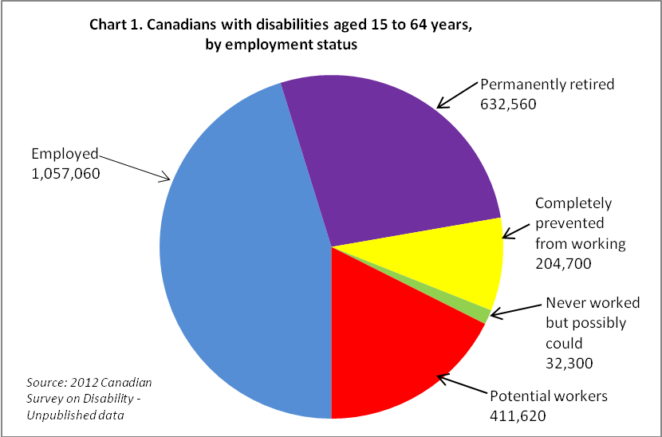

According to the 2012 CSD, there are an estimated 2,338,240 adults aged 15 to 64 years who reported having a disability. Almost half (1,057,060 or 45.2%) reported that they were employed at the time of the survey interview.

Among the remaining 1,281,180 adults with disabilities who reported that they were not currently employed, there are 892,100 adults with disabilities who are not considered to be potential workers. These individuals indicated that they are permanently retired (632,560), completely prevented from working because of their disability (204,700) or had never worked but possibly could (32,300). We acknowledge that some individuals in these three categories might consider employment in the future if their personal situation changes or if the environment changes (e.g. barriers to employment while in receipt of income support benefits are removed or modified). Appendix A of this report includes some basic demographic data and disability characteristics for these three populations as reported in the 2012 CSD.

There were then 411,620 who indicated through their responses that they were “potential workers.” These individuals are either actively seeking employment (ASE), stated that they will seek employment during the next 12 months (WSE), have previously worked and may seek employment (MSE), or are students not elsewhere classified. The majority (300,850 or 73.1%) are either actively seeking employment (the unemployed) or will be seeking employment during the next 12 months. Slightly more than one-fifth of potential workers (21.4%) have previous work experience but are not retired or completely prevented from working because of their disability. A very small proportion of potential workers (5.5%) are students who are not employed or actively seeking work or who said they plan to do so in the next 12 months. For the most part, this group consists of young people in high school or in a post-secondary program, many with limited work experience.

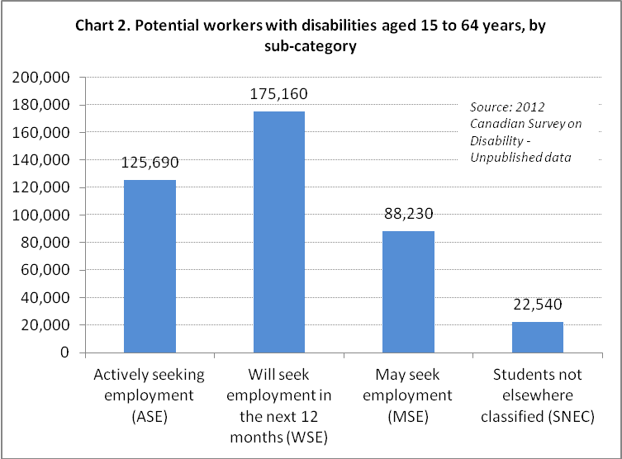

For the purpose of this report, we provide comparisons between two groups of persons with disabilities aged 15 to 64 years of age: those who are employed (1,057,060) and those who make up the population of potential workers (411,620). Where applicable, we will identify similarities and differences among the four sub-groups within the potential workers population: those who are actively seeking employment (ASE), those who will seek employment within the next 12 months (WSE), those who may seek employment in the future (MSE) and students not elsewhere classified (SNEC).

A profile of potential workers with disabilities
Potential workers with disabilities are not a homogeneous group. They are at different stages in their life cycle. Some are youth or young adults seeking their first job while still in school. Some are mothers returning to the work force after an absence to care for children. Some are older adults facing disability as a result of an accident or onset of a chronic health condition. There are, of course, many other sources of variability within this population, including the nature and severity of the disability, level of education, previous employment experience, and need for accommodation. Effective employment policies and programs that support the full integration of this diverse population into employment must be multi-faceted and supportive of a range of needs. To understand who these potential workers are and what their specific needs are, we have divided the population of potential workers into five age groups. Within each age group, we explore their demographic and disability characteristics and their employment experience, including accommodations needed and barriers encountered. We first offer a profile of the entire group followed by age-specific profiles that highlight their unique characteristics.

Potential workers with disabilities – Their demographic and socio-economic characteristics

Potential workers with disabilities are younger than those who are employed.

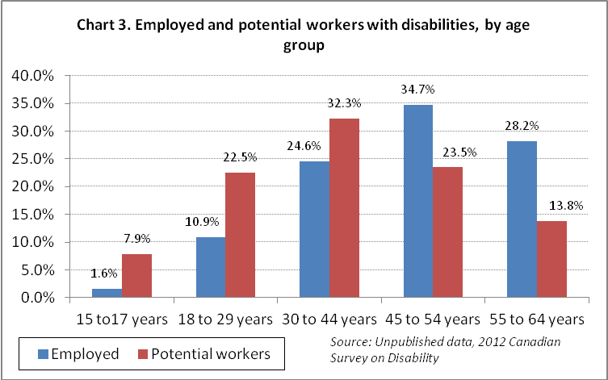

Chart 3 shows that the age distribution of potential workers with disabilities is quite different from that of those who are employed. Just over 30% of potential workers (125,310) are young adults under 30 years of age, 132, 930 (32.3%) are 30 to 44, 96,710 (23.5%) are 45 to 54 years of age and 56,680 (13.8%) are 55 years or older. By contrast, only one in eight people with disabilities who were employed in 2012 was under 30 years of age; more than 60% were 45 years or older.

As a result of population and workforce aging, considerable attention has been directed to strategies for retaining older workers (generally considered people aged 55 and older) in the workforce. These individuals often have considerable work experience and firm-specific knowledge. Some are aging with a disability; many others acquire a disability as a result of illness or injury later in life and could continue to work. The availability of short- and long-term disability leave and options to work reduced hours or have modified duties can be critical for the retention of older workers at a time when they still have much to contribute. Early and, especially, involuntary departure from the labour force due to a combination of ill health/disability and lack of workplace accommodation and support can be costly both for individuals and organizations. Effective return-to-work policies and procedures and responsive accommodations can do much to retain valued workers who might otherwise leave the labour force.

Potential workers with disabilities can face additional challenges because of lower levels of education.

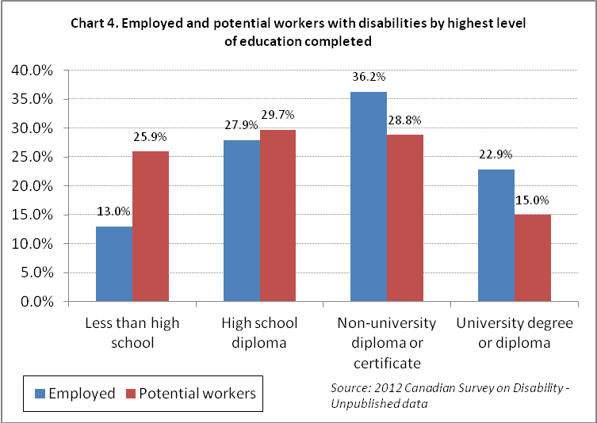

Slightly less than 44% of potential workers have a post-secondary credential compared to 59.1% of individuals with a disability who are employed. Among potential workers, 25.9% reported less than a high school diploma compared to 13% among the employed. To some extent, these differences reflect the fact that there are more young people among potential workers who are still in school or who may yet complete a post-secondary program. Nonetheless, both among the general population and in the population with disabilities, higher levels of education are associated with being employed, often with better earnings and career opportunities (Till et al, 2015). Despite this fact, disparities remain between persons with disabilities and their non-disabled counterparts, even among those who have obtained a college or university credential. Recent analyses of Canadian graduates of post-secondary programs indicate continuing disability-related disparities among graduates in both full- and part-time employment, as well as earnings, even when socio-economic variables are controlled for (Zarifa, Walters & Seward, 2015). These findings suggest that there is room for improvement in better accommodating students with disabilities in schools, colleges and universities and in facilitating their transition to the workforce.
"In terms of keys to my success, I think the biggest factor has been the training I received at university along with the opportunities for professional development training during my career." ~ Gary Birch

Other demographic characteristics include regional differences.

- Females are slightly more likely than males to be part of the “willing and able” population. 53% of potential workers are women compared to 51.3% of those who are employed.
- Given the age distribution, it is not surprising that more potential workers are living with their parents or living with unrelated people such as other students.
- Among those who are employed with disabilities, 4.4% identified as Aboriginal compared to 6.3% among potential workers. Among the employed, 15.2% are members of visible minority groups compared to 16.3% among potential workers.
- While across Canada, 28% of the labour force population aged 15 to 64 are potential workers, there is considerable variation across the provinces and territories. Three of the four Atlantic provinces and Nunavut have higher proportions in this group (Newfoundland and Labrador – 41.8%, Prince Edward Island – 32.1%, New Brunswick – 35%.4, and Nunavut – 36.8%). The proportions in both Saskatchewan and the Yukon are considerably lower than the national average, at 25% and 23.8% respectively.

Potential workers with disabilities – Their disability characteristics

Potential workers are more likely to report a cognitive disability.

Just over six out of 10 (61.1%) potential workers reported a cognitive disability, while among the employed, only 34.8% reported having a cognitive disability. Cognitive disabilities include memory, learning, developmental or a disability as a result of a mental health condition. It is important to note that many of these individuals also reported having a physical disability (flexibility, dexterity, mobility, pain) and/or a sensory disability (seeing, hearing).

The majority of people with disabilities reported more than one type of disability. Among the employed, 65% reported two or more types of disability; among potential workers, 78.1% reported two or more types.

The proportion of potential workers increases as severity of disability increases.

Persons with disabilities who are employed are more likely to be classified as having a mild or moderate disability, 45.9% and 22% respectively. Potential workers with disabilities include 28% who are classified as having a mild disability and 17.8% who have a moderate disability. Those who are classified as having a severe or very severe disability comprise 54.2% of potential workers and only 32.1% of those who are employed.

Potential workers with disabilities – Their employment experience
The nature and extent of questions asked in the 2012 CSD varies depending upon individuals’ labour force status at the time of the survey interview, as well as on the complex streaming within blocks of questions. For that reason, available information varies for each of the sub-groups within potential workers and sometimes for individuals within a sub-group. We will indicate the denominator for all charts and discussion.

Previous work experience differs significantly among the sub-categoies within potential workers.

The majority of potential workers have recent work experience. Fully three quarters had last worked in the five years preceding the survey and 44.8% had last worked in 2011 or 2012.

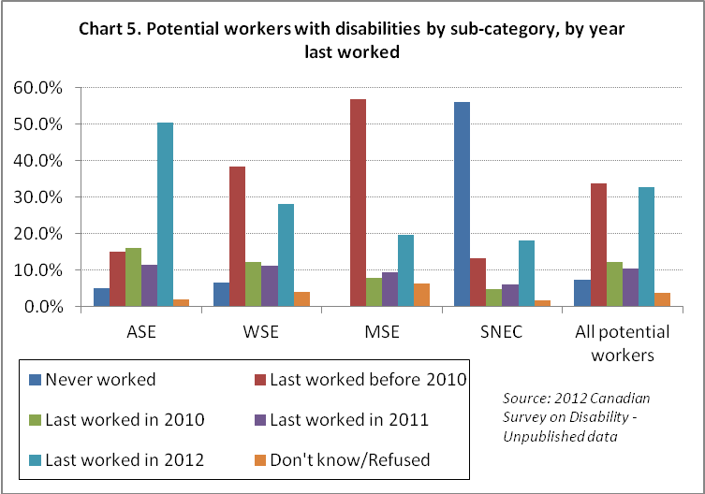

With respect to when they last worked, the four sub-categories of potential workers are very different. Among those actively seeking employment (ASE), the majority (61.8%) last worked in 2011 or 2012, and only 15.1% had last worked before 2010. Contrast this to the WSE sub-group where 39.1% have recent work experience (2011 and 2012) and 38.8% had last worked before 2010. Among those who have no specific intention of looking for work in the next year (the MSE sub-group), only 29% had recent work experience and more than half (56.8%) last worked before 2010. Among the SNEC sub-category, more than half (56%) have never worked.

Experiencing multiple periods of work interruption and unemployment makes it more difficult for individuals with disabilities to secure employment once out of a job, or to advance in a career (Yelin & Trupin, 2003). Intermittent or disrupted employment increases the risk of poverty and compromises access to employer-provided benefits, as well as eligibility for work-dependent benefits through programs such as Employment Insurance, CPP-D and Workers’ Compensation schemes. According to the OECD, finding new jobs for persons with disabilities is “considerably more difficult than helping them to stay in their jobs” (OECD, 2010), leading to recommendations for comprehensive disability management approaches that include injury/illness prevention, early assessment and intervention after the onset of illness, and effective retention and return-to-work strategies.

Over half of potential employees (53.8%) require workplace accommodations.

Workplace accommodations are needed by some workers with disabilities, but not all. The most common accommodations used by employees with disabilities and required by potential workers with disabilities are modified schedules, reduced work hours and modified work duties (Till et al, 2015 ). Other accommodations include physical modifications to the workplace (a modified or ergonomic workstation, handrails, ramps, widened doorways or hallways, accessible elevators, adapted or accessible parking, adapted washrooms); personal aids (human support, including a reader, Sign language interpreter, job coach or personal assistant); techncial aids (such as a voice synthesizer, a TTY, an infrared system or portable note-taker, specialized software or other adaptations for computer or laptop); communication aids (such as Braille or large print, recording equipment); and specialized transportation and/or specialized or adapted furniture (such as a special chair or back support).

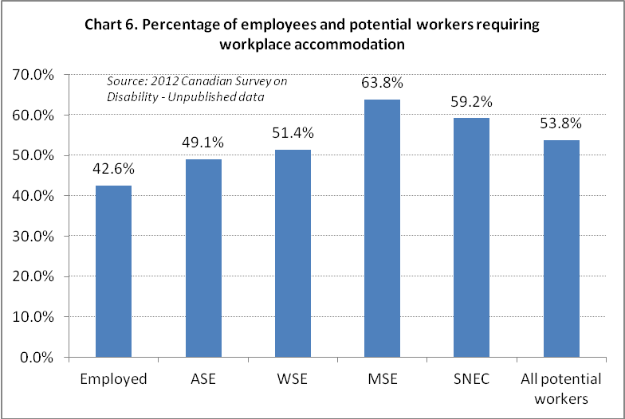

Only 42.6% of employees with disabilities who are currently employed require any workplace accommodation. Among potential workers, this increases to 53.8%, with 49.1% of individuals in the ASE sub-group requiring at least one accommodation. This increases to 51.4% for the WSE sub-group and to 63.8% for the MSE sub-group.

The need for workplace accommodation is greater among potential workers with disabilities than among their employed peers.

Based on the CSD, the majority of individuals with disabilities across Canada who are employed and require a workplace accommodation have employers who have met their needs and provided a range of acccommodations, from modified work hours to human support to modifications to the physical environment. Examination of Chart 7 shows that for both employees and potential workers, the most sought after accommodations are those most easily provided, often at low or no cost (modified hours, job redesign and flexible workplace options). The biggest differences between employees and potential workers are in the proportions who would require telework, some form of human support at work, computer modifications and more accessible physical environments.

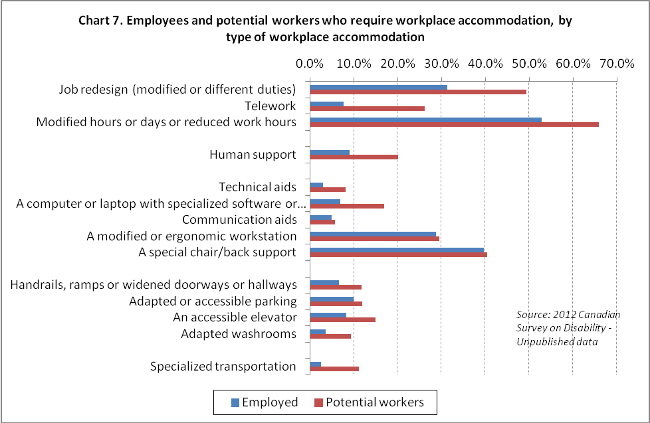

Among the 450,310 employed people with disabilities who require accommodation, the most sought after accommodation is modified hours or days or reduced work hours (52.8%). Almost two-thirds of the 221,450 potential workers who require workplace accommodation (65.9%) indicated that this would be a necessary accommodation.
"I may have a different way of doing my tasks at my own pace, but the job duties will be completed." ~Karen Lai

“"In terms of office organization, I needed help to get files in and out of filing cabinets, when I worked for government and for other offices. ….. . I was accommodated by having staff allocated to do those tasks for me."~ Jim Derksen
Some jobs may include activities that the worker with a disability is unable to do. Job redesign is an accommodation needed by 31.3% of the employed who require an accommodation, and is seen as a requirement for almost half (49.3%) of potential workers.

Telework is one accommodation that seems to be particularly important for potential workers. It was identified as necessary by 7.6% of the employed who required an accommodation. However, among potential workers, more than one in four (26.1%) who require an accommodation identified the need for a telework option.

While only 9% of the employed who needed an accommodation identified human support such as a reader, Sign language interpreter, job coach or personal assistant, the proportion more than doubles to 20.1% among potential workers who require an accommodation. A possible explanation for this increase is the fact that potential workers are more likely to have a developmental or learning disability than the employed.

6.9% of employees with a disability who require an accommodation identified the need for a computer or laptop with specialized software or other adaptations such as Braille, screen magnification software, voice recognition software or a scanner. Among potential workers, this proportion more than doubled to 16.8%.
"Given the type of work I do the most important accommodation that I require is access to computer technology. … As voice input technology improved I adopted using Dragon NaturallySpeaking as my primary method of inputting information into my computer. ~" Gary Birch

Almost three out of four potential workers in the WSE and MSE sub-groups have encountered at least one barrier that has discouraged them from looking for work.

Two of the sub-groups—those who will look for work in the next 12 months (WSE) and those who may seek employment in the future (MSE)—were asked a question about barriers or disincentives to employment they have encountered. These disincentives may have resulted in their being discouraged from looking for work. Respondents in these two sub-groups were provided with 11 statements, such as “Your expected employment income would be less than your current income,” and asked to answer “yes” or “no”. Almost equal proportions—72.6% and 73.9%, respectively—answered positively to at least one of the 11 statements.

Table 1. WSE and MSE sub-groups reporting encountering at least one barrier that discouraged them from looking for work
 | WSE | MSE | WSE and MSE
Number reporting at least one barrier | 127,250 | 65,190 | 192,440
Expected employment income would be less than current income | 27.1% | 21.0% | 25.0%
Would lose additional supports such as drug plan or housing | 22.1% | 17.5% | 20.6%
Lack of specialized transportation | 15.7% | 7.1% | 12.8%
Family responsibilities prevent working | 22.4% | 30.7% | 25.2%
Past attempts to find work have been unsuccessful | 42.1% | 24.7% | 36.2%
Family or friends discourage working | 14.7% | 8.3% | 12.5%
Have experienced discrimination in the past | 26.7% | 17.3% | 23.5%
Training or experience not adequate for current job market | 46.2% | 37.2% | 43.1%
Few jobs available in local area | 50.5% | 31.7% | 44.1%
Experienced accessibility issues when applying for work | 21.8% | 7.1% | 16.8%
Source: 2012 Canadian Survey on Disability - Unpublished data

A perceived lack of jobs available in their local area and the view that their training or experience is not adequate for the current job market are barriers that were most commonly encountered in the two sub-groups of potential workers who are not currently seeking employment.

In addition, more than one-third (36.2%) of the 192,440 respondents who encountered barriers that discouraged them from looking for work said that past attempts had been unsuccessful. Almost one-quarter (23.5%) said they had experienced discrimination.

Many potential workers are in receipt of income from disability support programs. Fear of less income through employment or loss of supports such as their drug plan or housing were disincentives reported by 25% and 20.6% of the 192,440 respondents in the WSE and MSE sub-groups of potential workers. Such findings are particularly pertinent to policy makers who wish to enable individuals with disabilities who receive government assistance to be able to participate in employment to the extent they are able to do so.

Potential workers with disabilities who worked since 2007 perceive more workplace discrimination than their currently employed peers.

All potential workers who held a job during the five years before the CSD interview were asked about their perceptions of workplace discrimination.
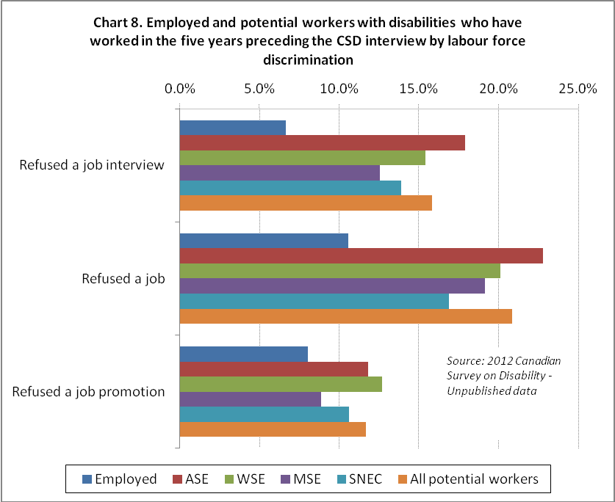

Despite the fact that discrimination in employment is prohibited under the Canadian Charter of Rights and Freedoms and the Canadian Human Rights Act, individuals with disabilities do experience discrimination. Chart 8 shows that many potential workers (15.8%) who had recent workplace experience believed they have been refused a job interview because of their disability. The proportion increases to just over one in five when asked about being refused a job, and 11.6% reported they believe they were refused a promotion. This is higher than the reported 8% reported by employed people with disabilities. A variety of macroeconomic, organizational and job-specific factors can affect employers’ willingness to hire, but clearly employers’ attitudes and concerns about costs, worker–job fit and acceptance by co-workers are major influencers, along with employees’ own skills and capacities (Kulkarni & Lengnick-Hall, 2014; Morris-Wales, 2010; Schur et al, 2009).

Both employed and potential workers with recent workplace experience were asked if they considered themselves to be disadvantaged in employment because of their health condition. Among those who are employed, 31.6% responded affirmatively; among potential workers with recent workplace experience, this increased to 45.5%.

When both groups were asked if their current employer (in the case of employed) or any potential employer (in the case of potential workers) would likely consider them to be disadvantaged in employment because of their health condition, 33.5% and 40.8% responded affirmatively. These findings point to attitudinal barriers that were not addressed in the 2012 CSD, but which have been summarized in some of the narrative accounts submitted by persons with disabilities to the CCD CURA project on Getting and Keeping a Job. Similarly, qualitative studies, such as Shier et al’s (2009) study of people with disabilities in Calgary and Regina, confirm that discrimination in the workplace from both employers and co-workers are key factors impeding workplace success.

Attitudinal barriers hinder people with disabilities from securing and/or retaining employment.

Authors of the CURA stories wrote about the negative attitudes that confront both job seekers and workers with a disability. Thirty-five authors (60% of the authors) focused on how negative attitudes are an impediment to job success. Their contributions emphasized the following themes.

- Employers may be influenced by stereotypes that portray people with disabilities as being less capable than people without disabilities.

As Marie Ryan stated, "Let’s go back for a minute to my foray into the world of work as a person with a disability - what would you have offered me if you had seen this woman in a [wheel]chair? - Would you have seen an asset, an opportunity or would you have determined my limitations because of who and what you saw? Would you have questioned my abilities and capacities because you saw a disability? Would you have directed me to the program for “those people” or would you have seen me as one who could contribute and form a vital member of the public service?"

- Paternalism remains an issue in some workplaces.

One of Susan Forster's employers identified the job accommodation that she believed Susan needed. Susan wrote, "Some years ago, I was offered a short-term contract with the Province of Ontario. During the interview process, I self-identified as legally blind. When we discussed accommodation, I was told about a former employee who was also vision impaired. She now held a position elsewhere in government. It was thought that the technical aids she used might interest me so a meeting was arranged. When we met, I noted that she had less vision than I, but in both eyes. I have usable vision in one eye only. I concluded that the large television screen she used as a computer monitor would not work for me. When I reported back, I stated that I would not need this aid. I was cheerfully informed that the device was already on order and [was] assured that I would love using it."

- Ableist ideas about disability are pervasive in Canadian society and people with disabilities are affected by these messages.

Some respondents acknowledged that they had to overcome their own negative views about themselves before seeking employment. Paul Young wrote, "The barriers that needed to be eliminated were my own, both physical and mental. My own disbelief in my ability to do the job, due to my experience of being segregated and congregated in a sheltered workshop, was one of the major barriers that had to be overcome."

Nine authors wrote about the importance of finding their own voice and using it to overcome barriers. These authors discussed how they had to become comfortable in discussing their impairments, barriers they encountered and accommodations that would transcend those barriers. These authors discussed how they used their communication skills to develop positive working relationships with colleagues who, in some instances, had a role to play in the accommodation process.

- It is sometimes necessary to work to make co-workers comfortable.

Paula Keirstead described how she had to make co-workers comfortable with her disability. She wrote, "Throughout my career, the barrier that needed to be addressed in all my jobs was people's discomfort with the fact that my eyes are crooked and their uncertainty of exactly how much I could see. This discomfort was often expressed through over-solicitous behaviour in trying to help me walk; and/or people looking over their shoulders wondering who I was looking at while in discussion with them. I found the best way to handle this was to just introduce my visual disability at the onset of our interaction and explain about my eyes being crooked, that I have no depth perception, and that I need a lot of light to man oeuvre independently, all with a bit of humour, and finally that I would ask for assistance when needed. I did this with employers, instructors, work colleagues, clients or whomever I thought needed to know or was obviously struggling with the situation. This eased anyone's anxiety and people adjusted quickly."

- There is the need to develop the vocabulary to discuss barriers and accommodations to overcome barriers.

Rhonda Wiebe explained, "The obstacles I face as a person with invisible disabilities are considerable. Slowly I’ve realized that these barriers are both within and outside of me, inexorably intertwined, with one bearing a tremendous impact on the other. Part of the process of overcoming them involves taking the personal step of learning to accept that I am the round peg which will not fit into the square hole of an eight-hours-a-day, five-days-a-week work life. That isn’t easy. I want to be that person, but once I acknowledged this reality, I needed to take a second step and assert to my employers that a different work pattern could still produce advantageous results. It meant summoning up the vocabulary and esteem to declare that accommodating my needs involved more than a one-time investment, like building a ramp or creating an accessible parking space. (Can’t see to drive anyway – the visual impairment kicked in fairly early.)"

A profile of potential workers – youth aged 15 to 17 years
According to the 2012 CSD, there are 54,990 youth with disabilities aged 15 to 17 years. Among this age group, 31.55% or 17,340 are employed, but the majority (32,510 or 59.1%) are potential workers. Even at this early age, there are an estimated 5,140 individuals who believed that they are completely prevented from working.

Youth aged 15 to 17 years represent 7.9% of the potential workers population. Among those 32,510 youth,
- 59.6% are male;
- 37.9% are aged 15, 30.5% are aged 16 and 31.6% are aged 17;
- 87.1% are attending school;
- 66.7% have a mild or moderate disability;
- the majority (73%) have a cognitive disability, including a learning disability (15,930), a developmental disability (11,000), a mental health disability (13,940) or a memory disability (7,710);
- 31.7% have a pain disability, 19.3% have a dexterity disability, 17.1% have a mobility disability and 15.3% have a flexibility disability; and
- 15.2% have a seeing disability and 8.6% have a hearing disability.

Of the 28,320 who are currently attending school, 58.4% require supports, including a teacher’s aid or tutor (11,880), a modified or adapted course curriculum (11,810), and/or extended time to take tests and exams (13,210).

More than half of youth with a disability who are potential workers (17,550 or 54%) have never worked. Among the 14,960 who have, the majority (10,250) last worked in 2012. Among the youth who are working, 81.4% require no workplace accommodation.

Only 42% (13,680) of potential workers age 15 to 17 reported that they would need an accommodation at work that includes job redesign (8,220), human support (8,110) and/or modified hours (7,290).

Among the 14,590 potential workers with work experience,
- 12.8% believed that they have been refused a job interview because of their condition;
- 12.5% believed that they have been refused a job because of their condition;
- 14.9% considered themselves to be disadvantaged in employment because of their condition; and
- 14.6% believed that an employer would likely consider them to be disadvantaged in employment because of their condition.

A profile of potential workers – young adults aged 18 to 29 years
According to the 2012 CSD, there are 251,660 young adults aged 18 to 29 years with disabilities. Among them, 114,840 (45.6%) are employed and 92,790 (36.9%) are potential workers. The remaining 44,030 (17.5%) of young adults reported that they are completely prevented from working or have permanently retired.

Slightly less than half of potential workers aged 18 to 29 years (46.7%) have a mild or moderate level of impairment; 53.3% are classified as having a severe or very severe disability; and 88.4% (33,330) reported at least one of the four types of cognitive disabilities (developmental, learning, memory or mental health; the most common being mental health).

The 92,790 young adults aged 18 to 29 years represent 22.5% of the 411,620 potential workers with disabilities. Among these, 25,620 are actively seeking employment (ASE), 43,280 will seek employment within the next 12 months (WSE), 15,260 may seek employment (MSE) and 8,640 are students not elsewhere classified (SNEC).

Almost one-third (28,660 or 30.9%) of potential workers in this age group are currently attending school. The majority are obtaining post-secondary education—11,580 are attending trade schools, colleges, CEGEPs or other non-university institutions, and 13,350 are attending university. In our preliminary analyses of this age group, we noted that there were significant differences among those who were attending school and those who were not. Therefore, we used this lens for the remainder of the analysis for this age group.

Of the 92,790 young adults with disabilities who are potential workers, 28,660 (30.9%) were attending school; the remaining 64,130 were not students at the time of the CSD interview. Table 2 following provides some demographics for these two populations.

Almost half (49.2%) of young adults with disabilities who are potential workers and who are attending school are aged 18 to 21 years, and the percentage decreases as age increases. The reverse is true for those who are not attending school. In this group, only 28.6% are aged 18 to 21 years, and the percentage increases as age increases.
Table 2. Demographic characteristics of youth with disabilities who are potential workers aged 18 to 29 years, by attending school status
Characteristic | Category | Currently attending school | Not attending school | Total
Total |  | 28,660 | 64,130 | 92,790
Age group | 18-21 | 49.2% | 28.6% | 35.0%
Age group | 22-25 | 32.7% | 32.2% | 32.4%
Age group | 26-29 | 18.1% | 39.2% | 32.7%
Sex | Male | 45.0% | 51.8% | 49.7%
Sex | Female | 55.0% | 48.2% | 50.3%
Marital status | Single | 85.6% | 79.8% | 81.6%
Family status | Living with parent(s) | 66.7% | 55.1% | 58.7%
Family status | Living with a spouse/partner | 14.3% | 18.9% | 17.5%
Family status | Living alone | 7.6% | 16.7% | 13.9%
Family status | Living with unrelated others | 9.0% | 3.6% | 5.3%
Aboriginal status | Aboriginal | 2.5% | 9.2% | 7.1%
Visible Minority status | Visible minority | 25.2% | 13.4% | 17.0%
Source: Unpublished data, 2012 Canadian Survey on Disability

School attendees are more likely to be female, while the reverse is true for those who are not attending school.

Both groups—those attending school and those who are not—are most likely to be living at home with their parents.

Those attending school are less likely to identify as Aboriginal (2.5% versus 9.2%) and are more likely to be a member of a visible minority (25.2% versus 13.4%).

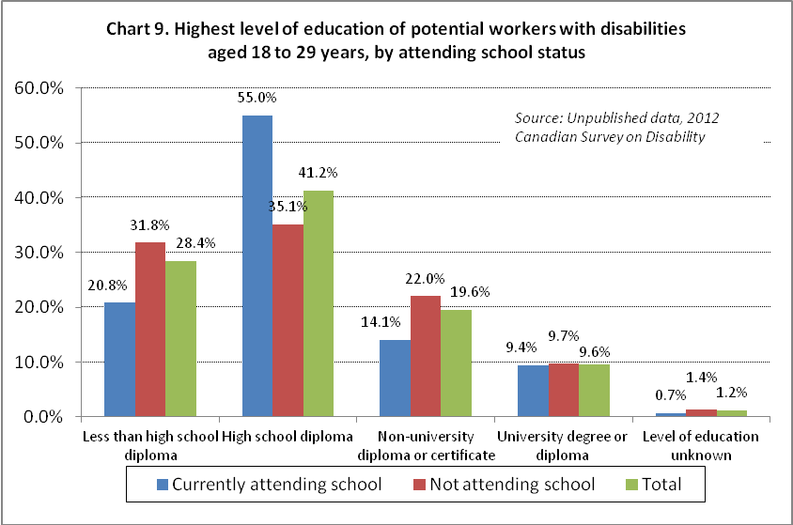

Chart 9 provides an interesting insight into the current status of youth with disabilities aged 18 to 29 years. It represents the highest level of education currently achieved. The good news is that those who are currently attending school are less likely to report less than a high school diploma than those who are not attending school (20.8% versus 31.8%). It is important to note that the majority of youth with disabilities who are attending school are attending post-secondary institutions (87% or 24,940).

Of the 28,660 potential workers among youth with disabilities aged 18 to 29 years who are attending school,
Table 3. Disability characteristics of youth with disabilities who are potential workers aged 18 to 29 years, by attending school status
Characteristic | Category | Currently attending school | Not attending school | Total
Total |  | 28,660 | 64,130 | 92,790
Type of disability | Seeing | 10.8% | 9.7% | 10.0%
Type of disability | Hearing | 13.0% | 8.9% | 10.2%
Type of disability | Mobility | 27.6% | 30.5% | 29.6%
Type of disability | Flexibility | 18.1% | 32.6% | 28.1%
Type of disability | Dexterity | 13.0% | 17.7% | 16.2%
Type of disability | Cognitive | 74.2% | 69.7% | 71.1%
Type of disability | Learning | 39.2% | 48.2% | 45.4%
Type of disability | Developmental | 22.1% | 16.1% | 18.0%
Type of disability | Memory | 19.6% | 25.1% | 23.4%
Type of disability | Mental health | 52.4% | 55.5% | 54.5%
Type of disability | Pain | 44.1% | 61.6% | 56.2%
Severity of disability | Mild | 36.4% | 29.4% | 31.6%
Severity of disability | Moderate | 22.7% | 19.1% | 20.2%
Severity of disability | Severe | 25.6% | 26.8% | 26.4%
Severity of disability | Very severe | 15.4% | 24.8% | 21.9%
Number of disabilities | 1 | 35.2% | 20.0% | 24.7%
Number of disabilities | 2 | 20.6% | 22.4% | 21.8%
Number of disabilities | 3 or more | 44.2% | 57.6% | 53.5%
Source: 2012 Canadian Survey on Disability – Unpublished data
- 74.2% (21,280) have a cognitive disability and, of those, 15,010 have a mental health disability and 11,230 have a learning disability;
- 27.6% have a mobility disability;
- 36.4% have a mild disability and 15.4% have a very severe disability; and
- just over one-third (35.2%) report only one type of disability.

Of the 64,130 potential workers among youth with disabilities aged 18 to 29 years who are not attending school,
- 69.7% (44,700) have a cognitive disability and, of those, 35,610 have a mental health disability, 30,910 have a learning disability and 10,330 have a developmental disability;
- 30.5% have a mobility disability;
- 29.4% have a mild disability and 24.8% have a very severe disability; and
- only 20% report only one type of disability.
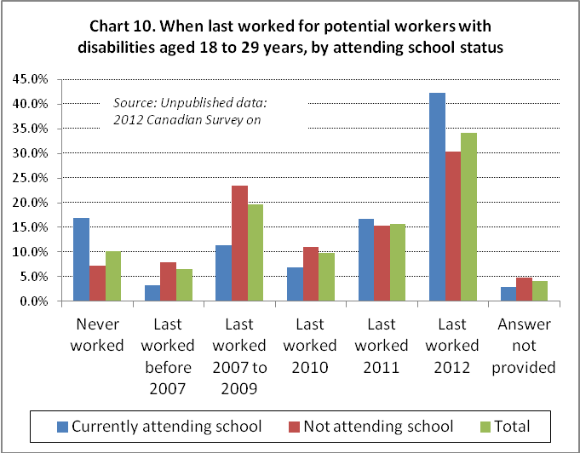

Chart 10 shows major differences in work experience between potential workers with disabilities aged 18 to 29 years who are attending school and those who are not. Those attending school are more likely than those who are not to be seeking their first job (16.9% versus 7.2%, respectively). In contrast, it is the opposite for those who indicated that they last worked in 2012, with 42.3% of those attending school reporting that they last worked in 2012 compared to 30.5% of those not attending school.

Potential workers aged 18 to 29 were also asked about their need for any workplace accommodation because of their condition. Almost half (48.9%) of those attending school said they did not require any accommodation; among those who are not attending school, this percentage dropped to 38.5%.

Among the 14,260 potential workers aged 18 to 29 years who are attending school who reported that they need a workplace accommodation,
- 55.4% need modified hours or days or reduced work hours;
- 47.6% need job redesign (i.e. either modified or different duties);
- 35.9% need human support, such as a reader, Sign language interpreter, job coach or personal assistant; and
- 30.3% need a computer or laptop with specialized software or other adaptation such as Braille, screen magnification software, voice recognition software or a scanner.

Among the 37,290 potential workers aged 18 to 29 years who are not attending school who reported that they need a workplace accommodation,
- 82.9% need modified hours or days or reduced work hours;
- 47.2% need job redesign (i.e. either modified or different duties);
- 37% need a special chair or back support;
- 35.8% require telework;
- 31.4% need a modified or ergonomic workstation; and
- 28.2% need human support, such as a reader, Sign language interpreter, job coach or personal assistant.

Respondents who had work experience and who are not actively seeking employment (ASE) were asked whether or not they encountered specific barriers while seeking employment.

Among those attending school,
- 38.8% reported no barriers; and
- of the 14,100 who did experience barriers,
  - 38.1% said there were few jobs available in the area;
  - 35.6% felt that their training or experience was not adequate for the current job market;
  - 20.9% reported that past attempts to find work were unsuccessful; and
  - 18.5% believed that the employment income would be less than their current income.

Among those not attending school,
- only 21.4% reported encountering no barriers; and
- of the 33,880 who did experience barriers,
  - almost half (47.2%) said there were few jobs available in the area;
  - almost half (46.4%) felt that their training or experience was not adequate for the current job market;
  - 21.8% believed that the employment income would be less than their current income; and
  - 20.2% had experienced discrimination in the past.

Potential workers with disabilities aged 18 to 29 years who had worked since 2007 were asked about their experience with discrimination in the context of seeking a job or a job promotion.

Among those who are attending school,
- 15.2% believed that they had been refused a job interview because of their condition;
- 21% believed that they had been refused a job because of their condition; and
- 6.4% believed that they had been refused a promotion because of their condition.

Among those who are not attending school,
- 22.1% believed that they had been refused a job interview because of their condition;
- 28.1% believed that they had been refused a job because of their condition; and
- 18.9% believed that they had been refused a promotion because of their condition.

A profile of potential workers – adults aged 30 to 44 years
According to the 2012 CSD, there are 487,760 adults aged 30 to 44 years with disabilities. Among them, 259,660 (53.2%) are employed and 132,890 (27.2%) are potential workers. The remaining 95,210 reported that they are completely prevented from working (43,660), have permanently retired (46,030) or have never worked (5,520).

Adults aged 30 to 44 years represent 32.3% of the 411,620 potential workers with disabilities. Among these, 44,200 are actively seeking employment (ASE), 54,310 will seek employment within the next 12 months (WSE), 30,400 may seek employment (MSE) and 4,020 are students not elsewhere classified (SNEC). Unlike the younger potential workers, almost two-thirds (62.2%) are female. In our preliminary analyses of this age group, we noted that there were significant differences between the two sexes; as a result, we used gender as the lens for the remainder of the analysis of this age group. Table 4 provides some demographics for these two populations.

Potential female workers with disabilities aged 30 to 44 years are younger than their male counterparts. Almost two out of five (38.5%) are aged 30 to 34 years, while among males, just over one in five are in this age group with a higher proportion aged 35 to 39.
Table 4. Demographic characteristics of adults with disabilities who are potential workers aged 30 to 44 years, by gender
Characteristic | Category | Males | Females | Total
Total |  | 50,250 | 82,640 | 132,890
Age group | 30-34 | 23.3% | 38.5% | 32.7%
Age group | 35-39 | 40.8% | 24.9% | 30.9%
Age group | 40-44 | 35.9% | 36.6% | 36.3%
Marital status | Single | 44.6% | 34.6% | 38.4%
Marital status | Married or living common law | 46.6% | 48.7% | 47.9%
Marital status | Separated, divorced or widowed | 8.4% | 16.7% | 13.6%
Family status | Living with parent(s) | 17.8% | 8.2% | 11.9%
Family status | Living with a spouse/partner, no children | 17.7% | 7.3% | 11.2%
Family status | Living with a spouse/partner and children | 27.6% | 41.1% | 36.0%
Family status | Lone parent | 5.5% | 29.0% | 20.1%
Family status | Living alone | 12.3% | 7.7% | 9.4%
Family status | Living with unrelated others | 19.0% | 6.7% | 11.3%
Source: Unpublished data, 2012 Canadian Survey on Disability

Males are more likely to be single (never married) than females (44.6% versus 34.6%). On the other hand, females in this population group are almost twice as likely to be separated, widowed or divorced than their males peers (16.7% versus 8.4%).

More females than males in this population group are part of a household that includes children (70.1% versus 33.1%) and females are more than five times more likely to be a lone parent (29% versus 5.5%). As well, females are less likely to be living alone (7.7% versus 12.3%) and are less likely to be living with unrelated others (6.7% versus 19%).

Of the 50,250 potential workers among adults with disabilities aged 30 to 44 years who are male,
- 61.2% (30,770) have a cognitive disability and, of those, 23,440 have a mental health disability and 11,050 have a learning disability;
- 46% have a mobility disability;
- 28% have a mild disability and 30% have a very severe disability; and
- 22.7% report only one type of disability.

Of the 82,640 potential workers among adults with disabilities aged 30 to 44 years who are female,
- 58.5% (48,340) have a cognitive disability and, of those, 42,060 have a mental health disability and 19,790 have a learning disability;
- 39.6% have a mobility disability;
- 31.1% have a mild disability and 20.4% have a very severe disability; and
- 28.5% report only one type of disability.

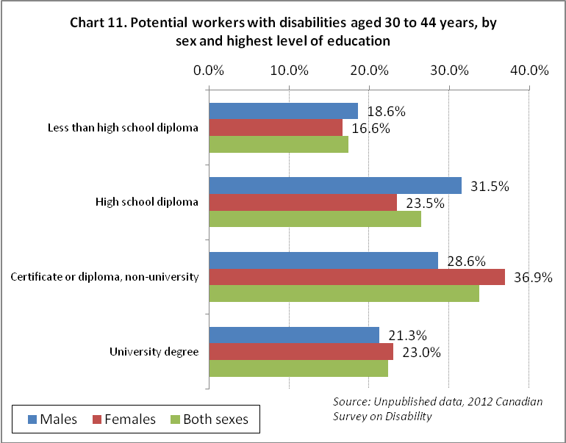

Chart 11 shows the difference in highest level of education attained by potential workers with disabilities aged 30 to 44 years when using the gender lens. Almost six out of ten females have some post-secondary education compared to just over five out of ten males.

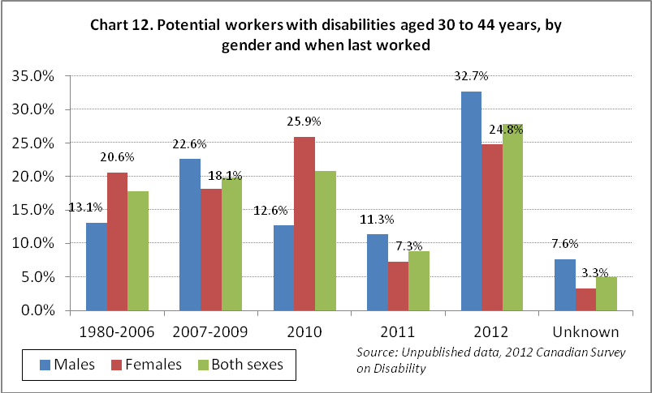

There are few potential workers aged 30 to 44 years who have never worked; the estimate is too small to be included in Chart 12. Amost two-thirds (64.6%) of female potential workers with disabilities aged 30 to 44 years last worked before 2011; among males, this drops to 48.3%.

Potential workers were also asked about their need for any workplace accommodation because of their condition, and 32.8% of males and 41.5% of females said they did not require any accommodation.

Among the 33,780 potential male workers aged 30 to 44 years who report that they need a workplace accommodation,
- 55 % need modified hours or days or reduced work hours;
- 46.7% need job redesign (i.e. either modified or different duties);
- 35.6% need a special chair or back support; and
- 23.4% need a modified or ergonomic workstation.

Among the 48,020 potential female workers aged 30 to 44 years who report that they need a workplace accommodation,
- 64.8% need modified hours or days or reduced work hours;
- 42.4% need job redesign (i.e. either modified or different duties);
- 39.1% need a special chair or back support;
- 29.2% need a modified or ergonomic workstation; and
- 20.2% need an accessible elevator.

Respondents who had work experience and who are not actively seeking employment (ASE) were asked whether or not they encountered specific barriers while seeking employment. Similar proportions of men and women reported experiencing one or more barriers, but there are interesting differences between men and women in terms of the extent to which some factors act as disincentives to employment.

Among males,
- 25.6% reported no barriers; and
- of the 23,780 men aged 30 to 44 who did experience barriers,
  - 34.3% felt that their training or experience was not adequate for the current job market;
  - 33.4% said there were few jobs available in the area;
  - 28.4% reported that past attempts to find work were unsuccessful;
  - 26.7% believed that they would lose their additional supports such as a drug plan or housing;
  - 22.4% believed that the employment income would be less than their current income; and
  - 21.9% reported that they had experienced discrimination in the past.

Among females,
- 23.4% reported encountering no barriers; and
- of the 43,500 who did experience barriers,
  - 54% felt that their training or experience was not adequate for the current job market;
  - almost half (49.8%) said that family responsibilities had prevented them from working;
  - 44.9% said there were few jobs available in the area;
  - 38.1% reported that past attempts to find work were unsuccessful;
  - 29.7% believed that the employment income would be less than their current income; and
  - 22.9% had experienced discrimination in the past.

Potential workers with disabilities aged 30 to 44 years who had worked since 2007 were asked about their experience with discrimination in the context of seeking a job or a job promotion.

Among males,
- 19.9% believed that they had been refused a job interview because of their condition;
- 28.4% believed that they had been refused a job because of their condition; and
- 14.7% believed that they had been refused a promotion because of their condition.

Among females,
- 14.1% believed that they had been refused a job interview because of their condition;
- 18.8% believed that they had been refused a job because of their condition; and
- 11.6% believed that they had been refused a promotion because of their condition.

Sixty percent of male potential workers with disabilities aged 30 to 44 years and 49.4% of females considered themsleves to be disadvantaged in employment because of their condition. Of this same group, similar proportions of males and females (44%) believed that their potential employer would likely consider them to be disadvantaged in employment because of their condition.

A profile of potential workers – adults aged 45 to 54 years
According to the 2012 CSD, there are 681,800 adults with disabilities aged 45 to 54 years. Among them, 366,900 (53.8%) are employed and 96,720 (14.2%) are potential workers. The remaining 218,180 (32%) reported that they are completely prevented from working (59,720), have permanently retired (154,520) or have never worked (3,940).

Adults aged 45 to 54 years represent 23.5% of the potential workers population. Among these, 29,700 are actively seeking employment (ASE), 40,890 will seek employment within the next 12 months (WSE) and 25,560 may seek employment (MSE). Of the 96,720 potential workers who are aged 45 to 54 years,
- 47.8% are male;
- the majority (61.8%) have a cognitive disability including a learning disability (22,410), a developmental disability (3,520), a mental health disability (51,000) and/or a memory disability (27,800);
- 80.6% have a pain disability;
- 16.5% have a mild disability and 31.8% have a very severe disability; and
- only 11.1% report having only one type of disability.

The majority (59.5%) acquired their disability after the age of 29. Among the 96,720 potential workers with disabilities aged 45 to 54 years,
- 19.6% report that their disability is as a result of an accident at work and 17.8% report that their disability is as a result of a non-work accident; and
- 21.8% report that the underlying condition that results in their disability is an illness or disease.

Of the 96,720 potential workers with disabilities who are aged 45 to 54 years, 57.1% have a post-secondary certificate/degree/diploma (42.3% non-university and 14.8% university); 19.1% have less than high school; and 23.7% have a high school diploma.

For the 29,700 who are actively seeking employment (ASE), the majority (78.7%) last worked in 2011 or 2012. For those who will seek employment in the next 12 months (WSE) and those who may seek employment (MSE), only 29.4% have recent work experience (which means they were employed in the two years previous to the CSD interview).

Of the 79,740 who were asked if they needed a workplace accommodation, 27.9% said no accommodation is required. For the remaining 57,470,
- 64.3 % need modified hours or days or reduced work hours;
- 51.3% need job redesign (i.e. either modified or different duties);
- 51.2% need a special chair or back support; and
- 33% said telework would be preferred.

Among the 60,800 potential workers with work experience,
- 24.1% believed that they have been refused a job interview because of their condition;
- 32.5% believed that they have been refused a job because of their condition;
- 17.5% believed that they have been refused a promotion because of their condition;
- 48.8% considered themselves to be disadvantaged in employment because of their condition; and
- 42.5% believed that an employer would likely consider them disadvantaged in employment because of their condition.

Respondents who had work experience and who are not actively seeking employment (ASE) were asked whether or not they encountered specific barriers while seeking employment. Of the 64,850 who were asked about barriers, 24.1% cited no barriers encountered. Of the 49,160 who did cite barriers,
- 48.8% reported that past attempts to find work were unsuccessful;
- 47.5% said there were few jobs available in the area;
- 44.1% felt that their training or experience was not adequate for the current job market;
- 33.8% reported that they had experienced discrimination in the past;
- 32.8% believed that the employment income would be less than their current income; and
- 24.6% believed that they would lose their additional supports such as drug plan or housing.

A profile of potential workers – adults aged 55 to 64 years
According to the 2012 CSD, there are 862,010 adults with disabilities aged 55 to 64 years. Among them, 298,340 are employed and 56,680 are potential workers. The remaining 506,990 reported that they are completely prevented from working (66,010), have permanently retired (425,670) or have never worked (15,310).

Adults aged 55 to 64 years represent 13.8% of the potential workers population. Among these, 18,200 are actively seeking employment (ASE), 21,500 will seek employment within the next 12 months (WSE) and 16,680 may seek employment (MSE).

Of the 56,680 potential workers who are aged 55 to 64 years,
- 40.2% have a cognitive disability;
- 75.7% have a pain disability;
- 29.9% have a mild disability and 25.6% have a very severe disability; and
- 22.2% reported having only one type of disability.

The majority (53.8%) acquired their disability after the age of 34. Among the 56,680 potential workers with disabilities aged 55 to 64 years, 32.5% reported that their disability is as a result of an accident at work.

Of the 56,680 potential workers with disabilities who are aged 55 to 64 years, 19.3% have a post-secondary certificate/degree/diploma (13.4% non-university and 5.9% university); 29.2% have less than high school; and 23% have a high school diploma.

For the 18,230 who are actively seeking employment (ASE), the majority (71.4%) last worked in 2011 or 2012. Among those who will seek employment in the next 12 months (WSE) and those who may seek employment (MSE), only 39% have recent work experience.

Respondents who had work experience were asked whether or not they encountered specific barriers while seeking employment. Of the 37,880 who were asked about barriers, 32.1% cite no barriers encountered. Of the 25,710 who did cite barriers,
- 23.5% reported that past attempts to find work were unsuccessful;
- 42.3% said there were few jobs available in the area;
- 30.9% felt that their training or experience was not adequate for the current job market; and
- 19.3% believed that the employment income would be less than their current income.

Among the 40,500 among potential workers with work experience,
- 10.7% believed that they have been refused a job interview because of their condition;
- 13.5% believed that they have been refused a job because of their condition;
- 8.6% believed that they have been refused a promotion because of their condition;
- 42% considered themselves to be disadvantaged in employment because of their condition; and
- 39.5% believed that an employer would likely consider them to be disadvantaged in employment because of their condition.

The existing employment environment
Interviews were conducted with five disability community leaders. These individuals have experience with employment policy, as well as knowledge related to hearing impairment, mental health, vision impairment, mobility impairment and the issues experienced by newcomers with disabilities from multicultural communities. The interviews focused on four questions, and these key informants’ responses are summarized in this section of the report.

What policies act as barriers to the labour market participation/employment of people with disabilities?

Employment policies for people with disabilities have not been developed in a manner consistent with a truly human rights approach to increasing equality in the labour market.

The appropriate approach to policy development would be to employ an intersectional lens (i.e. recognizing that individuals have multiple intersecting identities, such as gender, race and disability and, as such, will face a range of intersecting barriers related to those identities). An intersectional lens is particularly important for women and girls with disabilities to more fully address the vulnerability, labour force exclusion and lack of support they experience.

Complexity was a reoccurring theme with policies not keeping pace with the challenges.

Improving employment opportunities for persons with disabilities was identified as one of the more challenging problems facing the disability community. Examples include the steps an individual with a disability has to take to find a job, supports for employers, and the interplay between the income security system, the employment system and the human rights system.

There are multiple windows for job seekers to navigate.

It was highlighted that it is difficult for the public to understand how to navigate recruitment points in the federally regulated employment sector. There are a variety of different recruitment bodies, and the Internet has become a gateway for learning about and applying for employment opportunities.

Reliance on the internet as a portal to employment opportunities is a barrier.

For some people with disabilities, there continues to be a digital divide. Poverty and limited access to disability-related supports make it difficult for some people with disabilities to be active in the online world. In addition, despite the Jodhan case, where the Federal Court of Appeal reaffirmed that the Government of Canada violates constitutional equality rights when it posts inaccessible information on its websites, people with disabilities continue to encounter inaccessible information on government websites and elsewhere.

There are multiple windows for employers to navigate.

A range of impairment-specific organizations have emerged to address the needs of particular disability communities. As a result, employers have a myriad of organizations to contact when identifying the employment opportunities available to people with disabilities. On the positive side, there is a wealth of expertise with whom to consult; however, this patchwork of organizations can be confusing for employers as they attempt to determine which organizations they should contact.

There are disincentives to employment in the income security system.

There was concern expressed regarding the interplay between the employment and income security systems, with criticism of municipal, provincial and federal income programs. It was suggested that significant reform―and not tinkering—was needed in the income security system to improve employment opportunities for people with disabilities. Income programs were seen to be inflexible, and problems were identified related to earning exemptions, allowable assets and difficulty in qualifying for benefits.

There was an emphasis on facilitating transitions between income security programs and employment. It was explained that disincentives in the income security system are particularly problematic for people who experience mental health concerns. As it is difficult to qualify for income security programs, people with episodic disabilities, such as mental health consumers who have qualified, must decide if they can risk experimenting with employment. If they experience a re-occurrence of their disability, they may find themselves in a situation where they have to contend with both working toward restoring themselves to wellness and meeting the eligibility criteria of the income security system from which they need benefits. If there were a better safety net in the income security system that met the needs of people with episodic disabilities, then they would be able to work when they are well, and when they are unable to work because of their disability, they would have an expedited re-entry to the income security system where they could access the necessary benefits.

Some income security programs include additional benefits, such as access to prescription medication, and this was noted as a particularly important benefit for consumers of mental health services. Linking benefits to receipt of income supports was singled out as a barrier.

Some employment programs include criteria that exclude some people with disabilities.

An example of this is wage subsidies that are only available to people who are under the age of 30. Such exclusionary criteria fail to take into account barriers in the environment that prevent some people with disabilities from meeting career milestones at the same rate of progress as people without disabilities.

Some policies limit the type of disability-related supports that are available and the level of coverage.

Disability-related supports are key to successful employment outcomes for some persons with disabilities. There are barriers related to maintaining personal technology, such as computers, which are an essential component in the job-search process.

Other examples that were highlighted related to the lack of post-training supports to help people attain employment, such as coaches who help people prepare for job interviews where they will discuss disability-related accommodations; the lack of readers for persons with vision impairments; and insufficient access to accessible public transportation.

Some policies that have been implemented to improve the employment opportunities of people with disabilities have had limited results.

Wage subsidies encourage the hiring of people from specific groups, such as students, people from visible minorities, Aboriginal and First Nations people, women and people with disabilities. An example of a wage subsidy in the Canadian context is the Opportunities Fund-Wage Subsidy (OF-WS). Wage subsidies were criticized because they frequently do not lead to permanent employment for people with disabilities.

What policies act as facilitators to the labour market integration/employment of people with disabilities?

Policies that support skill acquisition for people with disabilities

Skills acquisition improves employment opportunities for people with disabilities. In particular, apprenticeships and college training were emphasized.

Policies that enable the disability community to deliver employment services and programs

Disability community organizations that do the following were identified as improving employment outcomes for community members:
- connect employers and job seekers with disabilities;
- provide pre-employment training;
- create social enterprises where people with disabilities are supported and accommodated in employment; and
- train people to be, for example, peer support workers.

Policies that target the recruitment of people with disabilities

When undertaking targeted recruitment, employers can reach out to organizations in the disability community that have connections to qualified job seekers with disabilities. Potential collaborators include:
- organizations of people with disabilities;
- independent living centres; and
- employment programs for people with disabilities.

Policies that motivate employers to put aside ableist attitudes and hire people with disabilities

Despite the misgivings about wage subsidies already described, they were nevertheless recognized as having some value, because they act as levers whereby people with disabilities gain work experience and access to jobs, even if the employment may be temporary. For newcomers with disabilities, acquiring Canadian experience is an important milestone.

While the cost of accommodation is not an undue hardship for large employers, it can present a barrier for smaller employers. Tax incentives were identified as a policy to facilitate the hiring and accommodation of people with disabilities by small business.

What are the policy gaps that most affect your community?

Lack of good jobs, particularly full time jobs with benefits

The changing nature of work is one example as it is no longer expected that someone will enter a “job for life.” Rather, there is a prevalence of non-standard forms and types of employment. As well, there is significant entry-level part-time work available—most of which does not provide benefits and/or security. The extra costs of disability make it difficult for some people with disabilities to accept low-paying jobs.

Inadequate level of support available to individuals as they try to enter the labour market

While some policies have the potential to create positive change, the level of support for implementation is insufficient to achieve equality in employment. As a result, some policies were identified as both barriers and facilitators. For example, wage subsidies were considered as positive because they facilitate entry into the workplace; however, these are short-term and often do not result in permanent employment. The disability community has a dwindling capacity, and so organizations available to support individuals with disabilities to access the labour market are few and they are often under-funded.

Inadequate effort to educate employers about the employment barriers encountered by people with disabilities

Employers continue to have stereotypical attitudes about the capabilities of people with disabilities, and this affects hiring because non-disabled people cannot imagine how someone with abilities different from their own will accomplish tasks. Despite the fact that significant work has been done to address stigma associated with mental illness, the education has not been sufficiently inclusive.

What are the lessons that you take away from promising employment policies/practices that you are aware of?

Lifelong learning plays an integral role in improving employment outcomes for persons with disabilities.

Inclusive and integrated education programs from K to 12 are considered absolutely essential as a first step on the path to employment.

Individuals with disabilities need to develop career self-management skills.

In addition to the education and skills that a person needs to become qualified in a particular field of employment, individuals need career self-management skills to support obtaining and retaining a job. There are organizations in the disability community, such as Independent Living Centres, that help people with disabilities acquire the skills, including self-management skills, that will help them advance their careers.

Health maintenance was a career self-management skill that was singled out. There are very good workplace programs, including one by the Canadian Mental Health Association. There are also knowledge and self-management strategies to keep employees well within a workplace so that they can succeed at their work.

Employees and managers need ongoing education on stigma, discrimination, human rights in the workplace, managing stress in the workplace and mental health first aid.

The National Standard of Canada for Psychological Health and Safety in the Workplace is a new program. It is a standard that is going to be used in Canadian workplaces to make sure that people maintain a level of wellness, and it also provides people with tools to identify when mental health and stress are becoming a factor in an individual’s work. The program teaches individuals to recognize the symptoms of mental illness and ensure that there are policies and practices in place so that people with mental illness will feel comfortable and confident to disclose their issues or when they are not feeling well.

There are mechanisms in place for remedying barriers and concerns.

Despite provincial, national and international human rights laws, people with disabilities continue to experience discrimination. The 2015 Annual Report of the Canadian Human Rights Commission states “58 percent of the complaints received by the Commission were on the ground of disability and 40 percent of the disability complaints were related to mental health issues, which means that 23 percent of the complaints received by the Commission in 2015 related to mental health” (Canadian Human Rights Commission).

For employees experiencing difficulties on the job, Employee Assistance Programs (EAPs) provide support to enable them to address behaviours that could have a negative impact on their work, health and safety.

An organizational ombudsman is a neutral party in an organization who can facilitate the resolution of concerns brought forward by employees, managers and other stakeholders by reframing issues and developing options for addressing those concerns. Another key role for this office can be identifying necessary systemic change. An ombudsman may also coach people to assist them to develop the skills necessary to bring forward concerns on their own. This coaching function could help people with disabilities gain the vocabulary and self-confidence necessary to, for example, advocate for accommodation.

Conclusions

Analysis of the 2012 CSD allows exploration of the characteristics of potential workers with disabilities—those who are not employed, but who could be. This information is crucial in order to have a realistic benchmark for assessing the effects of public policies designed to improve employment opportunities and reduce the social exclusion that so many people with disabilities experience. We estimate that, in 2012, 411,620 individuals with disabilities aged 15 to 64 belonged to this category of potential workers.

The diversity that exists among the population of potential workers with disabilities needs to be recognized.

- Almost three-quarters are either actively seeking employment or plan to within 12 months. 44.8% had last worked in the two years preceding the survey, and three-quarters had last worked in the previous five years.

- Compared to their employed counterparts, potential workers include a large proportion that are young (30% are under 30 years of age). Policies that focus on transitions to post-secondary education and to employment are particularly important for this group whose early experiences in the labour force are critical for skills development and for providing a foundation for employment success and self-confidence. Almost 44% of potential workers had a post-secondary credential, and a sizeable number are students who combine work and study or who plan to seek employment upon graduation.

- Slightly less than half of potential workers have a mild or moderate disability; somewhat more than half will require a workplace accommodation. Like their employed counterparts, these accommodations most often involve modified work schedules, reduced hours or modified duties. The capacity to telework is also important for potential workers, and a somewhat higher proportion will need technical aids, a modified workstation or physically accessible work environments.

- Opportunities for training and skills development are important, both to meet employers’ needs and to reduce one of the more common barriers to employment. Other disincentives that can be addressed through policy development include ensuring that potential workers do not sacrifice important benefits such as drug plans or subsidized housing for employment, or wind up with less income than they would have on public assistance programs. Family responsibilities for care for children or other family members can also compete with employment, particularly for women with disabilities. Having experienced discrimination in hiring or promotion is another issue that can lead to discouragement when attempts to find work are unsuccessful.

- Continuing research—both quantitative and qualitative—is important to better address the issues that affect employment in this diverse population. The views and experiences of persons with disabilities and key informants/leaders in the disability community affirm that changes in employers’ attitudes, programs that target the recruitment of people with disabilities and support a strengths-based approach to training, placement and vocational supports, and a proactive approach to remedying barriers to employment are all essential for progress to be made toward full inclusion.

Appendix A
Characteristics of persons with disabilities age 15-64 who are
not employed and not considered potential workers

Characteristic |  | Permanently retired | Completely prevented from working | Never worked but possibly could
TOTAL |  | 632,560 | 204,700 | 32,300
Age group | 15-17 | 6,340 | 3,890 | 1,210
Age group | 18-29 | 6,340 | 31,420 | 6,320
Age group | 30-44 | 46,030 | 43,660 | 5,520
Age group | 45-54 | 154,520 | 59,720 | 3,940
Age group | 55-64 | 425,670 | 66,010 | 15,310
Gender | Male | 287,330 | 94,940 | 7,030
Gender | Female | 345,230 | 109,760 | 25,270
Marital Status | Legally married (and not separated) or living common law | 388,010 | 81,540 | 10,310
Marital Status | All other | 244,550 | 123,160 | 21,990
Census family structure | Spouse/partner without children | 268,730 | 35,080 | 4,010
Census family structure | Spouse/partner with children | 117,490 | 45,690 | 6,300
Census family structure | Lone parent | 52,720 | 18,600 | 1,410
Census family structure | Child | 25,210 | 41,370 | 6,360
Census family structure | Person living alone | 142,270 | 31,830 | 1,970
Census family structure | Person not in a census family | 26,150 | 32,130 | 12,250
Aboriginal identity | Aboriginal | 32,960 | 12,470 | 1,370
Visible minority | Visible minority | 71,750 | 27,460 | 14,060
Highest certificate, diploma, degree | Less than high school | 171,500 | 96,680 | 19,270
Highest certificate, diploma, degree | High school diploma | 192,310 | 54,620 | 12,210
Highest certificate, diploma, degree | Non-university diploma or certificate | 176,250 | 35,420 | 830
Highest certificate, diploma, degree | University degree or diploma | 88,100 | 16,060 | ..
Highest certificate, diploma, degree | Unknown/refused | 4,400 | 1,920 | ..
.. Data suppressed

Characteristic |  | Permanently retired | Completely prevented from working | Never worked but possibly could
TOTAL |  | 632,560 | 204,700 | 32,300
Severity of disability | Mild | 114,130 | 20,100 | 3,970
Severity of disability | Moderate | 115,420 | 25,500 | 5,680
Severity of disability | Severe | 146,440 | 57,770 | 13,440
Severity of disability | Very severe | 256,570 | 101,340 | 9,220
Type of disability | Developmental | 17,310 | 43,030 | 6,260
Type of disability | Dexterity | 233,050 | 75,590 | 5,250
Type of disability | Emotional | 232,230 | 120,060 | 20,260
Type of disability | Flexibility | 439,420 | 136,180 | 15,690
Type of disability | Hearing | 124,650 | 37,460 | 10,670
Type of disability | Learning | 128,920 | 87,570 | 17,720
Type of disability | Memory | 137,220 | 59,800 | 14,220
Type of disability | Mobility | 422,800 | 132,310 | 9,410
Type of disability | Pain | 512,140 | 148,540 | 23,590
Type of disability | Seeing | 161,120 | 48,040 | 6,180
Type of disability | Type unknown | 10,700 | .. | ..
Number of disabilities | 1 | 106,940 | 19,490 | 3,470
Number of disabilities | 2 | 90,530 | 24,340 | 2,300
Number of disabilities | 3 | 105,650 | 31,230 | 3,910
Number of disabilities | 4 | 99,410 | 37,550 | 8,020
Number of disabilities | 5 | 90,590 | 36,840 | 12,390
Number of disabilities | 6 to 10 | 139,440 | 55,260 | 2,220
Age of onset of first disabling condition | Before school (0-4) | 32,900 | 32,000 | 5,910
Age of onset of first disabling condition | 5 -18 (school years) | 47,640 | 20,300 | 6,760
Age of onset of first disabling condition | 19-29 (in transition) | 60,410 | 38,900 | 5,250
Age of onset of first disabling condition | 30-44 (early work years) | 194,820 | 58,100 | 5,250
Age of onset of first disabling condition | 45-54 (middle work years) | 161,800 | 35,000 | 3,370
Age of onset of first disabling condition | 55-64 (later work years) | 116,730 | 17,400 | 11,020
Age of onset of first disabling condition | Unknown | 18,260 | 3,100 | 11,020
.. Data suppressed

References

Arim, R. (2015). A profile of persons with disabilities among Canadians aged 15 years or older, 2012. Canadian Survey on Disability, 2012. Statistics Canada Catalogue no. 89-654-X. ISBN 978-1-100-25046-5.

Canadian Human Rights Commission (2015). People First: 2015 Annual Report to Parliament. http://www.chrc-ccdp.gc.ca/eng/content/annual-report-2015

Erickson, W. A., von Schrader, S., Bruyère, S. M & VanLooy, S. A. (2014). The employment environment: Employer perspecties, policies, and practices regarding the employment of persons with disabilities. Rehabilitation Counselling Bulletin, 57 (4), 195-208.

Government of Canada (2013). Rethinking Disability in the Private Sector. Report from the Panel on Labour Market Opportunities for Persons with Disabilities. Cat. No.: HS64-21/2013E-PDF. ISBN: 978-1-100-21661-4.

Houtenville, A. J. & Ruiz, T. (2011). Annual disability statistics compendium: 2011. Durham: University of New Hampshire, Institute on Disability.

Konrad, A. M., Moore, M. E., Ng, E. S. W., Doherty, A. J. & Breward, K. (2013). Temporary work, underemployment and workplace accommodations: Relationship to well-being for workers with disabilities. British Journal of Management, 24, 367-382.

Kulkarni, M. & Lengnick-Hall, M. L. (2014). Obstacles to success in the workplace for people with disabilities: A review and research agenda. Human Resource Development Review, 13, (2), 158-180.

Morris-Wales, J. (2010). Literature review on job retention and career progression for persons with disabilities in Canada and internationally. A report prepared for Human Resources and Skills Development, Canada.

OECD (2010). Sickness, Disability and Work: Breaking the Barriers- Canada: Opportunities for Collaboration.

Schur, L., Kruse, D., Blasi, J. & Blanck, P. (2009). Is disability disabling in all workplaces? Workplace disparities and corporate culture. Industrial Relations, 48 (3), 381-410.

Shier, M., Graham, J. R. & Jones, M. E. (2009). Barriers to employment as experienced by disabled people: A qualitative analysis in Calgary and Regina, Canada. Disability & Society, 24, (1), 63-75.

Statistics Canada (2012). Canadian Survey on Disability, 2012: Concepts and Methods Guide. http://www.statcan.gc.ca/pub/89-654-x/89-654-x2014001-eng.htm

Taskila, T., Shreeve, V., Laghini, M. & Bevan, S. (2015). Living long, working well: Supporting older workers with health conditions to remain active at work. The Work Foundation, Lancaster University. http://www.theworkfoundation.com/DownloadPublication/Report/386_Living_long_working_well_Final.pdf

Till, M., Leonard, T., Yeung, S. & Nicholls, G. (2015). A profile of the labour market experiences of adults with disabilities among Canadians aged 15 years and older, 2012. Canadian Survey on Disability, 2012. Statistics Canada Catalogue no. 89-654-X2015005.

Turcotte, M. (2014). Persons with disabilities and employment. Insights on Canadian Society. Statistics Canada Catalogue no. 75-006-X. ISSN 2291-0859.

Wright, R. (2001). Tapping the talents of people with disabilities: A guide for employers.
Ottawa: Conference Board of Canada.

Yelin, E. & Trupin, L. (2003). Disability and the characteristics of employment. Monthly Labor Review, May: 20-31.

Zarifa, D., Walters, D. & Seward, B. (2015). The earnings and employment outcomes of the 2005 cohort of Canadian postsecondary graduates with disabilities. Canadian Review of Sociology, 52 (4) 343-376.

Because the latter group was predominantly older and there was insufficient information to determine if they would be open to re-entering the labour force, they were excluded from the definition of potential workers.
The number in the SNEC sub-group is too small to be released.
The number in the SNEC sub-group is too small to be released.
Inclusive Education Canada (IEC) explains that "Inclusive education means that all students attend and are welcomed by their neighbourhood schools in age-appropriate, regular classes and are supported to learn, contribute and participate in all aspects of the life of the school."

